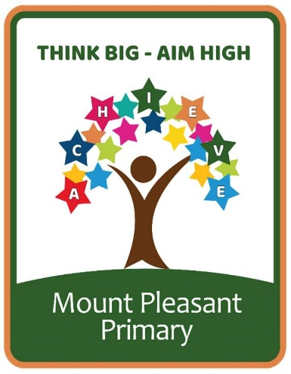
Religious Education Curriculum
At Mount Pleasant Primary School, we follow the Kirklees Agreed Syllabus, Believing and Belonging.

MPPS Religious Education Long Term Plan
EYFS | E.4 Who belongs in my family and community? | E.5 How do people celebrate special times?  Christmas (Nativity) | E.1 Which places are special to members of our community? | E.2 Why are some objects special? | E.3 Who cares for me and how do I help others? | E.6 How do we understand and care for the world?
Year 1 | C1.6 Which books and stories are important?  (7 lessons) | C1.1 What does it mean to belong a community of belief?  (12 lessons)  Visit or visitor from the local church |  | F1.12 How and why do we care for others? (Pathway 3)  (7lessons) | C1.5 Why are festivals important in a community?  (7 lessons)  Eid-ul-Fitr (April) | Spirited Arts Competition
Year 2 | C1.3 How can we make good choices?  (8 lessons) | C1.4 How and why do some people pray?  (8 lessons) | F1.15 What did Jesus teach and how did he live? (Pathways 3 and 6)  (8 lessons)  Easter |  | C1.2 How are symbols used to welcome new life?  Ask a visitor or parent who has had a baby to come and visit our school (7 lessons) | Spirited Arts Competition
Year 3 | CL2.6 How do Jews use stories to remember God’s covenant?  (7 lessons) | CL2.2 How do different people express their spirituality?  (6 lessons) | FL2.11 How do creation stories help people understand the world? (Pathway 6) | (7)CL2.4 Why do the lives of the Gurus inspire Sikh believers? (10 sessions)  Plan a visit to a Sikh Gurdwara  Vaisakhi (April) |  | Spirited Arts Competition
Year 4 | CL2.1 What faiths and beliefs can be found in our country and community? (6 sessions) | CL2.5 How do ancient stories influence modern celebrations? (7 sessions) Diwali (October) | CL2.3 How do the 5 pillars help Muslims to lead a good life? (9 sessions)  Visit a mosque or visitor |  | FL2.14 How are the stories of Holy Week important to Christians? (Pathway)  (5 sessions) | Spirited Arts Competition
Year 5 | CU2.4 Why do some people go on pilgrimage? (7 sessions)  Rosh Hashanah-Yom Kippur (October) | FU2.12 Should we forgive others? (Pathway 3)  (5 sessions) | CU2.3 What values do people live by? (10 sessions) |  | CU2.6 What do Christians believe about the old and new covenants? (6 sessions)  Visit or visitor to a synagogue. | Spirited Arts Competition
Year 6 | CU2.2 How do Sikhs symbolise their commitment?  (5 sessions) | CU2.1 What do Hindu people believe about God? (7 sessions)  Visit or have visitor from Hindu temple. | CU2.5 How and why are Jewish festivals celebrated today?  (6 sessions) | FU2.13 Why are rites of passage important? (Pathways 2 and 4)  (7 sessions) |  | Spirited Arts Competition

