**Mount Pleasant Primary School**

**Evidencing the impact of the Primary PE and Sports Premium 2024-25**

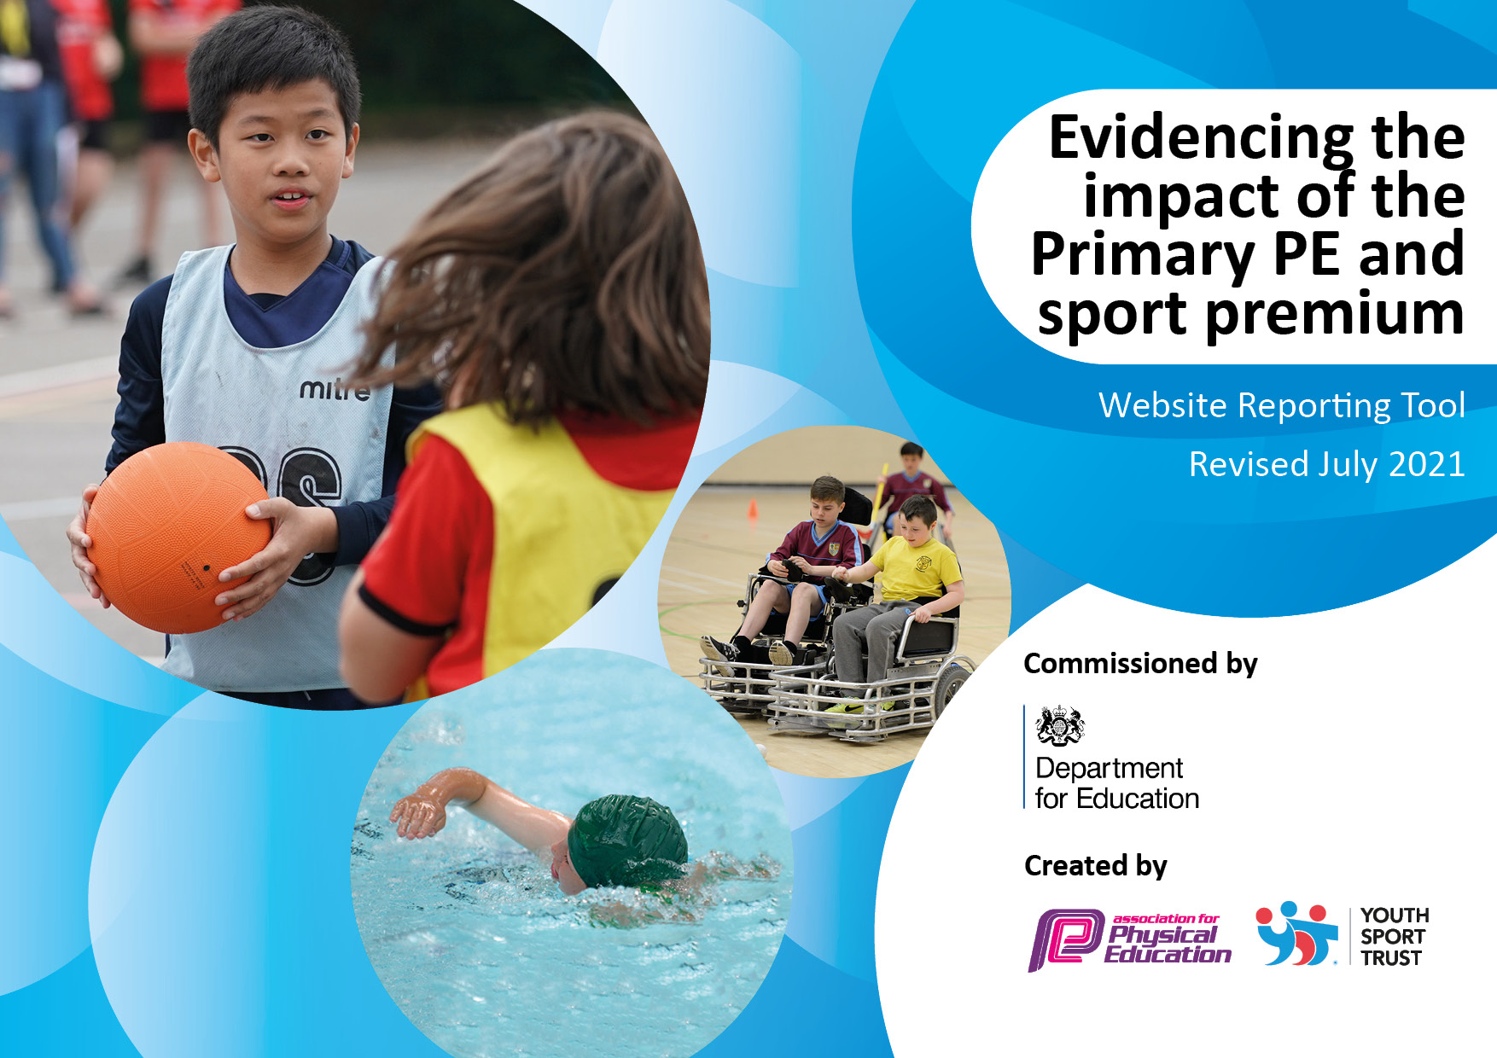

**Details with regard to funding**

Please complete the table below.

|  |  |
| --- | --- |
| Total amount carried over from 2023/24 | £0 |
| Total amount allocated for 2024/25 | £21,500 |
| How much (if any) do you intend to carry over from this total fund into 2024/25. | £0 |
| Total amount of funding for 2024/25. To be spent and reported on by 31st July 2025 | £21,500  Actual spend - £22,400 |

**Swimming Data**

Please report on your Swimming Data below.

|  |  |
| --- | --- |
| Meeting national curriculum requirements for swimming and water safety.  N.B. Complete this section to your best ability. For example, you might have practised safe self-rescue techniques on dry land which you can then transfer to the pool when school swimming restarts.  **Due to exceptional circumstances priority should be given to ensuring that pupils can perform safe self-rescue even if they do not fully meet the first two requirements of the NC programme of study** | To be completed in July 2025 |
| What percentage of your current Year 6 cohort swim competently, confidently and proficiently over a distance of at least 25 metres?  **N.B.** Even though your pupils may swim in another year please report on their attainment on leaving primary school at the end of the summer term 2020.  Please see note above | % |
| What percentage of your current Year 6 cohort use a range of strokes effectively [for example, front crawl, backstroke and breaststroke]?  Please see note above | % |
| **What percentage of your current Year 6 cohort perform safe self-rescue in different water-based situations?** | % |
| Schools can choose to use the Primary PE and sport premium to provide additional provision for swimming but this must be for activity **over and above** the national curriculum requirements. Have you used it in this way? | No |

**Action Plan and Budget Tracking**

Capture your intended annual spend against the 5 key indicators. Clarify the success criteria and evidence of impact that you intend to measure to evaluate for pupils today and for the future.

|  |  |  |  |  |
| --- | --- | --- | --- | --- |
| **Academic Year:** 2024/25 | **Total fund allocated:** | **Date Updated: November 2024** | |  |
| **Key indicator 1:** The engagement of all pupils in regular physical activity – Chief Medical Officers guidelines recommend that primary school pupils undertake at least 30 minutes of physical activity a day in school | | | | Percentage of total allocation: |
| £15,660 70% |
| **Intent** | **Implementation** | | **Impact** |  |
| Your school focus should be clear what you want the pupils to know and be able to do and about  what they need to learn and to  consolidate through practice: | Make sure your actions to achieve are linked to your intentions: | Funding allocated: | Evidence of impact: what do pupils now know and what can they now do? What has changed? | Sustainability and suggested next steps: |
| To engage least active children with focused play and lunch time activities | Deploy Lunch time Sports Coach to target least active during lunch times in KS2.  Deploy Sports Coach to work with least active for an extra PE session weekly.  Teachers target least active children during PE lessons.  Update resources for play and lunch times (based on pupil voice), so children are excited and use them.  Deploy Sports coach from Huddersfield Town to raise motivation and promote girls and football and sports in general.  One lunchtime, target UKS2 girls and an after school girls and sports club.  Purchase Beyond the Physical Resources to ensure PE teaching focuses on developing children’s fundamental skills. | £5,850  £2,500  (part of SPIN package)  £2000  £3,500  £570 | Least active engaged with physical activity every lunch time.  They are motivated with choice of resources and activities on offer.  Children know the importance of physical exercise.  Least active are engaged with resources.  Least active and girls are given opportunities to work with HTFC coach and are motivated and engaged.  All children have access to and engage with the new PE scheme – developing their fundamental skills. | Set up individual challenges, so children can motivate and engage themselves with physical activities.  Least active are now active and enjoy physical activities and understand its importance.  Girls in particular are confident in taking part in sports related activities, including football.  Beyond the Physical scheme is embedded. |
| To engage Reception children in daily physical activity. | Purchase bikes for Reception pupils. | £12,040 | All Reception children have access to bikes on a daily basis.  All children are supported to ride the bikes and develop their motor skills. | All children are confident in using the bikes. |
| To raise attainment in swimming to meet requirements of the national curriculum. | Additional swimming session to allow for smaller numbers of children.  Purchase new in school site swimming pool, led by Swimschool.  This will enable pupils to have intense daily lessons.  Children who did not pass in their first year will have a second opportunity to take intense swimming lessons. | Costed through school budget | Children leave Year 6 able to:   * Swim competently, confidently and proficiently over a distance of at least 25 metres. * Use a range of strokes effectively, for example, front crawl, backstroke and breaststroke. * Perform a safe self-rescue in different water-based situations | Children do not learn how to swim prior to school lessons, and therefore require longer time to become familiar with being in a pool. |
| Use the new racetrack and equipment with challenges to promote physical fitness. | Children have access to a high quality play equipment, such as trim trail, race track to develop their fitness levels. | Costed through the school budget | All children from Y2-6 have access to this area either at playtime or lunchtime.  Children increase their physical activities and enjoy the challenges | This will be a high-quality implementation with 10-year guarantee. Challenges will be changed yearly to keep motivation and excitement. All children will be able to access this area through careful timetabling of play and lunch times. As well as during the school day and as an after-school club |
| Ensure appropriate resources are available for the teaching of PE. | Audit resources and replenish | £2000 | All planned PE sessions are fully resourced leading to greater participation and activity in lessons.  Equipment audit by PE coordinator linked to club planning shows all activities are well resourced. | Continued monitoring of PE resources for wear and tear and devise purchasing plan to ensure all sports offered during the day and through after school clubs are adequately resourced.  Continue to widen range of resources so a wider variety of choice is available for children. |
| **Key indicator 2:** The profile of PESSPA being raised across the school as a tool for whole school improvement | | | | Percentage of total allocation: |
| £1500 7% |
| **Intent** | **Implementation** | | **Impact** |  |
| Your school focus should be clear what you want the pupils to know and be able to do and about what they need to learn and to consolidate through practice: | Make sure your actions to achieve are linked to your intentions: | Funding allocated: | Evidence of impact: what do pupils now know and what can they now do? What has changed? | Sustainability and suggested next steps: |
| To actively encourage pupils to take on leadership roles that support the delivery of sport and physical activity within the school. | Sports leaders are recruited and trained to be Play Leaders through the Sports Coach.  Play Leaders promote active play and are positive role models for the younger children. | Part of SPIN package. | Children complete Play Leaders training.  They are knowledgeable about how to organise small games and activities that can be used during lunchtimes, breaks and outside school hours.  Increased opportunities for children to lead their own games at playtime and lunchtime. | All taught games are embedded, and children are able to set up their own games and activities and are active. |
| Embed physical activity into the school day through encouraging active travel to and from school and active break times lunchtimes. | Resources purchased for play and lunch times to encourage active play.  Children are taught about importance of physical activity.  All staff promote active play.  EYFS – every child has access to outdoors daily, and timetabled sessions in the Woodland to promote active play through use of climbing frame and large space.  Encourage families to walk to school, or at least park the car further away from the school to ensure walking to and from school. | Costed in above | Visible range of outdoor activities to encourage active play.  Children understand importance of physical activities to health and mental well-being. | As above |
| Celebrate school achievements through social media and across the school community. | Dedicate a school display board to PE and sports.  Dedicate time to share sports teams’ achievements at assemblies. This will encourage others to aspire to be involved.  Raise profile through regular events and information being shared on parent Newsletter and social media. | Release time to update displays through cover supervisors | The profile of sport is raised across school.  Children are inspired to take part in new activities.  Increased awareness of school’s sporting achievements in pupils and parents | This becomes a regular feature of school communication. |
| Improve signposting of community links by regularly sharing updates with local clubs on School Ping and also regular PE updates in the newsletter. | Regularly share information and updates regarding local sports events and activities on School Ping and on the Parents’ Notice board. |  | Parental feedback indicates they are aware of local offers especially in the holidays. | As above |
| To further raise the profile of PE and Sport within the school and the local community, creating an improved sense of enthusiasm of participation and pride in the school amongst pupils. | PSHE Week July 2025- children participate in a wide range of activities and enjoy sessions in new sports activities.  Raise the profile of sport by engaging with coaching staff and linking to career aspirations within sport / exercise (Aspirations Week May 2025) | £1500  Admin time to organise the event. | Children understand the importance of healthy lifestyles and importance of mental wellbeing.  They are able to talk about which healthy activities they enjoy taking part in and the impact of these to their health.  Aspirations are raised in the sports careers. | PSHE and Aspirations Week are regular and embedded features within the school. |

|  |  |  |  |  |
| --- | --- | --- | --- | --- |
| **Key indicator 3:** Increased confidence, knowledge, and skills of all staff in teaching PE and sport | | | | Percentage of total allocation: |
| £4,240 19% |
| **Intent** | **Implementation** | | **Impact** |  |
| Your school focus should be clear | Make sure your actions to | Funding | Evidence of impact: what do | Sustainability and suggested |
| what you want the pupils to know | achieve are linked to your | allocated: | pupils now know and what | next steps: |
| and be able to do and about | intentions: |  | can they now do? What has |  |
| what they need to learn and to |  |  | changed? |  |
| consolidate through practice: |  |  |  |  |
| To maintain and raise the standards of pupil attainment and progress in PE by increasing teacher confidence, knowledge, and skills through professional development. | PE Leads to monitor the quality of PE curriculum from Beyond the Physical, to ensure it continues being high quality, progressive.  Staff use Beyond the Physical to upskill their PE teaching and confidence.  Engage PE Coach through SPIN Partnership to work with teachers across the school to develop teacher confidence and competence levels.  PE Lead receive regular training and time.    Professional development in subject leadership for PE subject leader, through termly whole day sessions with SPIN.  PE leads seek teacher and pupil’s views of PE in school. | Costed through school core budget  £4,240 (Part of SPIN membership)  X3 training sessions and release time for subject leaders. | Curriculum plans show clear progression and well sequenced teaching sequences.  As a result of good leadership and more confident and knowledgeable staff, pupils in all year groups made good or better progress in PE. | PE Lead continue to share CPD and implement strategies from level 4 qualification and from their own training through staff meetings. |
| **Key indicator 4:** Broader experience of a range of sports and activities offered to all pupils | | | | Percentage of total allocation: |
| £0 0% |
| **Intent** | **Implementation** | | **Impact** |  |
| Your school focus should be clear | Make sure your actions to | Funding | Evidence of impact: what do | Sustainability and suggested |
| what you want the pupils to know | achieve are linked to your | allocated: | pupils now know and what | next steps: |
| and be able to do and about | intentions: |  | can they now do? What has |  |
| what they need to learn and to |  |  | changed? |  |
| consolidate through practice: |  |  |  |  |
| Continue to offer a range of sports and physical after school clubs to encourage more pupils to take up sport and physical activities | Enrichment Lead reintroduces after school clubs, which also promotes sports and physical activities.  Purchase after school club from HTFC to target girls and football. | Enrichment coordinator release time.  Cover for staff – through the school staffing budget.  Costing already stated above | Good participation numbers in after-school clubs  Pupil Voice will show an increased enjoyment in after school clubs. | Skills, talents and achievements have been celebrated which in turn have raised children’s self-confidence and positivity towards sports and physic al activity.  Regularly share results from intra and inter-school competitions on the school’s Twitter page. |
| Offer additional physical activities, such as bicycle club. | Use Bicycles, helmets etc purchased last year to teach children how to ride a bike.  This will take place on the school grounds; once children have become proficient, they will undertake outside, road bicycle proficiency course through Bikeability. | Release time for trained staff to take children in weekly lessons, | Trained staff.  Children unable to ride a bicycle before can now do so, ensuring that bikeability sessions can focus more on road proficiency.  Children are more active and enjoy riding bicycles.  Children and parents appreciate the health benefits associated with bikes. | Staff are fully trained to continue offering this club in the future.  Initial large cost of bikes will only need supplementing once bikes need replacing.  Children encouraged to bring own bikes to school. |
| Teach children about health and well-being through activities regarding diet, exercise and how to be ‘mentally’ healthy. | As part of PSHE and PE sessions, children are taught about healthy lifestyles and the positive impact of these.  PSHE week has a number of health and wellbeing activities to celebrate healthy lifestyles, including healthy cooking, scoot-fit sessions, sports interschool tournaments, and competitions. | PSHE and PE leads released for subject leadership time. | Children are able to say what they need to do to be healthy. |  |
| Continue to develop the School Garden as another element of physical activity. | Garden lead ensures all year groups have a bedding plot to grow vegetables and fruit. Throughout the year, children look after their plot, water and then harvest.  Children are taught that gardening is another form of being active. | Garden resources from school budget | Children report enjoyment of these sessions, mental wellbeing and healthy lifestyles developed | Children enter competitions for the food they grow.  Parents take an active involvement in the School Garden. |

|  |  |  |  |  |
| --- | --- | --- | --- | --- |
| **Key indicator 5:** Increased participation in competitive sport | | | | Percentage of total allocation: |
| £1000 4% |
| **Intent** | **Implementation** | | **Impact** |  |
| Your school focus should be clear | Make sure your actions to | Funding | Evidence of impact: what do | Sustainability and suggested |
| what you want the pupils to know | achieve are linked to your | allocated: | pupils now know and what | next steps: |
| and be able to do and about | intentions: |  | can they now do? What has |  |
| what they need to learn and to |  |  | changed? |  |
| consolidate through practice: |  |  |  |  |
| To increase the number of intra-school and inter-school opportunities for pupils. | PE leads to coordinate at least 8 intra-school tournaments through SPIN.  PE leads organise inter-school tournaments between classes throughout the year. | £1000  Staffing costs | Children possess the necessary competitive skills (e.g. resilience, determination, empathy) | Apply for school Games Mark in 2024 – 2025.  Achieved Bronze and Silver previously.  Awarded Gold award  Maintain Gold Award |

|  |  |
| --- | --- |
| Signed off by | |
| Head Teacher: | Naeem Nazir |
| Date: | November 2024 |
| Subject Leader: | Stacie Samuels |
| Date: | November 2024 |
| Governor: | Tim Archer |
| Date: | November 2024 |